ACROPOLIS INSTITUTE OF TECHNOLOGY AND RESEARCH
Department of Information Technology

Synopsis
On
Autonomous AI Agent

Introduction
  - Overview
Artificial Intelligence (AI) has rapidly advanced from simple rule-based systems to intelligent systems capable of autonomous reasoning and decision-making. One of the most significant developments in modern AI is the creation of Autonomous AI Agents, which are systems that can independently understand user goals, plan tasks, execute actions, and generate results without continuous human supervision. These agents simulate human-like intelligence by combining natural language understanding, task planning, memory, and tool usage.
An Autonomous AI Agent operates through a continuous intelligent loop consisting of goal interpretation, task planning, action execution, observation, and replanning. The agent first interprets the user’s goal using Natural Language Processing (NLP), then breaks it down into smaller tasks using a planning module. It uses external tools such as web search engines, calculators, APIs, and file systems to gather information and perform required operations. The agent also includes a memory system implemented using vector databases, which allows it to store and retrieve information efficiently for future use. This enables the system to learn from previous interactions and improve its performance over time.
The proposed system integrates Large Language Models (LLMs) such as GPT, which provide advanced reasoning, language understanding, and decision-making capabilities. Frameworks such as LangChain or CrewAI are used to manage task planning, tool integration, and execution workflows. The system also includes a backend for processing and a frontend interface for user interaction.
This project focuses on designing and implementing a fully functional autonomous AI agent that can perform real-world tasks such as research assistance, travel planning, coding support, and intelligent information retrieval. The system demonstrates key AI concepts such as autonomous decision-making, intelligent planning, tool utilization, and memory management.
The development of this project contributes to the advancement of intelligent automation systems and provides a foundation for future applications in personal assistants, automation tools, and enterprise AI solutions.

  - Purpose
The purpose of this project is to design and develop an Autonomous AI Agent that can independently understand user goals, plan and execute tasks, use external tools, and generate accurate results with minimal human intervention. Unlike traditional AI systems that only respond to direct user input, the proposed system is capable of intelligent decision-making, task planning, and autonomous execution by following a structured goal-oriented workflow.
The project aims to create an AI agent that can interpret natural language input provided by the user and convert it into meaningful and actionable goals using Natural Language Processing (NLP) techniques. Once the goal is identified, the system will break it down into smaller sub-tasks using a planning module. These tasks will then be executed sequentially using an execution engine that interacts with various tools such as web search engines, APIs, calculators, and file systems to collect information and perform operations. This enables the system to solve complex, multi-step problems automatically.
Another important purpose of this project is to implement an intelligent memory system using vector databases such as FAISS or Chroma. This memory system allows the agent to store, retrieve, and utilize information from previous interactions, improving its ability to provide accurate, context-aware, and efficient responses. The memory system enhances the agent’s performance over time by enabling learning-like behavior and reducing redundant operations
The project also focuses on integrating advanced Large Language Models (LLMs) such as GPT, which provide powerful reasoning, language understanding, and response generation capabilities. These models help the agent analyze goals, generate plans, make decisions, and produce meaningful outputs. Frameworks such as LangChain or CrewAI are used to manage task planning, tool integration, and execution flow, enabling smooth coordination between different components of the system.
Additionally, the purpose of this project is to demonstrate the practical implementation of autonomous agent architecture, including modules such as goal interpreter, planner, decision engine, tool layer, memory system, execution engine, and output generator. This provides hands-on experience in designing and developing real-world AI systems and understanding how modern intelligent agents operate.
This project also aims to provide a scalable and flexible system that can be applied in various domains such as research assistance, travel planning, job search automation, coding assistance, and intelligent virtual assistants. By automating complex tasks, the system improves efficiency, reduces human effort, and increases productivity.
Furthermore, this project helps in understanding key Artificial Intelligence concepts such as autonomous systems, task planning, decision-making, tool integration, vector databases, and intelligent automation.
Overall, the purpose of this project is to develop a fully functional autonomous AI agent that demonstrates intelligent behavior, automation capabilities, and real-world applicability, thereby contributing to the advancement of intelligent systems and modern AI technologies.

Literature Survey
  - Existing Problem
With the rapid growth of Artificial Intelligence, many intelligent systems such as chatbots, virtual assistants, and recommendation systems have been developed to assist users in various tasks. However, most existing AI systems are limited in their functionality and lack true autonomy. These systems are primarily reactive, meaning they only respond to direct user queries without the ability to independently plan, execute, and complete complex tasks. They do not have the capability to understand long-term goals or perform multi-step problem-solving.
One of the major limitations of traditional AI systems is the absence of task planning and decomposition. When a user provides a complex goal, such as planning a trip or conducting research, existing systems cannot break the goal into smaller tasks or determine the sequence of actions required to achieve it. Instead, they provide general responses without executing the necessary steps to complete the task. This makes them inefficient for solving real-world problems that require structured planning and execution.
Another significant limitation is the lack of autonomous decision-making capability. Most existing systems require continuous human supervision and input at every step. They cannot independently decide what action to take next, which tool to use, or how to adjust their actions based on new information. This reduces their effectiveness and limits their use in automation applications.
Existing AI systems also lack proper memory mechanisms. They do not have the ability to store and retrieve past interactions or learned information in an efficient manner. As a result, they cannot use previous experiences to improve performance or provide context-aware responses. This leads to repetitive processing and reduced efficiency, especially when handling complex or recurring tasks.
Furthermore, traditional systems have limited or no capability to interact with external tools such as web search engines, APIs, databases, or file systems autonomously. They rely mainly on pre-trained knowledge, which may be outdated or incomplete. This restricts their ability to provide real-time, accurate, and updated information.
Another important problem is the lack of an execution engine that can perform tasks automatically. Most systems cannot perform actions such as searching for information, calculating results, retrieving files, or executing workflows independently. This prevents them from functioning as fully autonomous intelligent agents.
Additionally, existing systems often suffer from issues such as inaccurate responses, lack of context awareness, inability to adapt to new situations, and inefficient handling of complex workflows. These limitations reduce their practical usability in real-world applications such as automated research, intelligent assistants, task automation, and decision support systems.

  - Proposed Solution
To overcome the limitations of traditional AI systems, the proposed solution is to design and develop an Autonomous AI Agent that can independently understand user goals, intelligently plan tasks, use external tools, store and retrieve memory, and execute actions automatically. The system is designed to function as an intelligent, goal-driven agent that follows a structured workflow to complete tasks without requiring continuous human intervention.
The proposed system begins with the Goal Interpreter module, which processes the user’s input using Natural Language Processing (NLP) techniques and converts it into a structured and meaningful goal. This allows the system to understand the user’s intent accurately. Once the goal is identified, the Planner Module analyzes the goal and divides it into smaller, manageable sub-tasks. Task decomposition enables the system to handle complex problems efficiently by solving them step-by-step.
The Decision Engine plays a crucial role in controlling the overall workflow of the system. It determines which task should be executed next, selects appropriate tools, evaluates task progress, and decides whether to continue execution, replan tasks, or generate the final output. This enables the system to function autonomously and adapt to different situations.
The Tool Layer provides the agent with access to external tools such as web search engines, APIs, calculators, and file systems. These tools allow the agent to retrieve real-time information, perform calculations, and interact with external data sources. This enhances the agent’s capability to perform real-world tasks accurately and efficiently.
The Execution Engine is responsible for carrying out the tasks generated by the planner. It executes each task sequentially, interacts with tools when necessary, and generates intermediate results. The execution engine ensures that all tasks are completed in the correct order and according to the plan.
The system also includes a Memory Module that uses vector databases such as FAISS or Chroma to store and retrieve information. This memory system allows the agent to remember past interactions, store useful information, and retrieve relevant data when needed. This improves the efficiency, accuracy, and context-awareness of the system by reducing redundant processing and enabling intelligent information reuse.
The Output Generator module collects all intermediate results and generates a final response using Large Language Models (LLMs) such as GPT. The output is presented to the user in a clear and understandable format.
The proposed system integrates modern AI frameworks such as LangChain or CrewAI to manage task planning, tool integration, and execution workflows. Backend technologies such as FastAPI or Flask are used to handle system operations, while frontend interfaces such as web dashboards or mobile applications allow users to interact with the agent easily.

Theoretical Analysis
  - Block Diagram
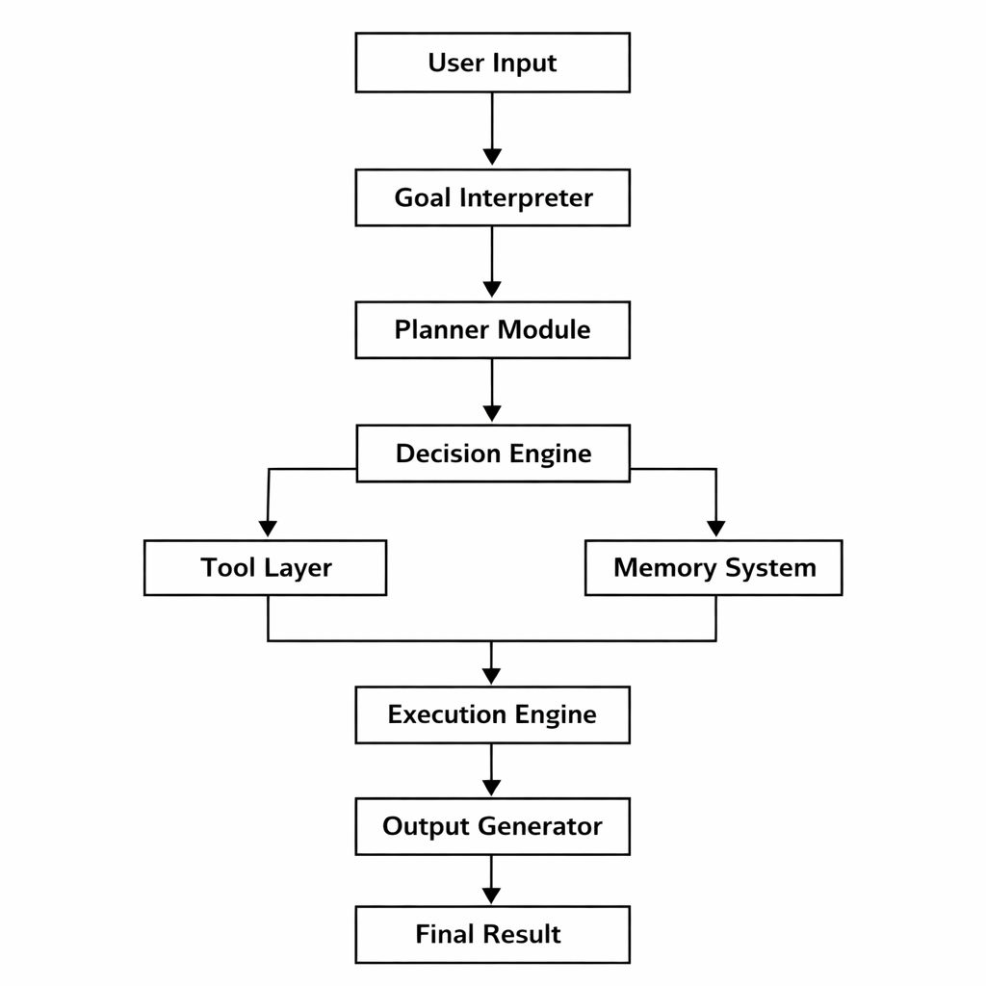
Fig 3.1 Block Diagram

  - Hardware/Software Designing

Hardware Requirements:
- Laptop/Desktop: Minimum 8 GB (16 GB recommended)
- Storage: 256 GB or more recommended
- Internet Connection: Required for API access and web search

Software Requirements:
- Languages: Python 3.10 or above
- Libraries & Frameworks: LangChain, OpenAI API, NumPy, Pandas.
- Frontend: Streamlit
- Backend: FastAPI or Flask
- Databases:ChromaDB or FAISS
- Development Tools: Visual Studio Code, Git & GitHub

Applications
The Autonomous AI Agent developed in this project has wide applications in various domains where intelligent automation, decision-making, and task execution are required. The system can independently understand user goals, perform task planning, use tools, and generate accurate results, making it useful in both personal and professional environments.
1. Research Assistance:
The AI agent can act as an intelligent research assistant by automatically searching for information from various sources, collecting relevant data, summarizing content, and presenting useful insights. This helps students, researchers, and professionals save time and improve productivity by automating the research process.
2. Travel Planning:
The system can help users plan trips by searching for travel destinations, hotels, transportation options, and budget estimates. It can generate complete travel plans, including schedules, cost analysis, and recommendations, making travel planning easier and more efficient.
3. Coding Assistant:
The autonomous AI agent can assist programmers by generating code, debugging errors, explaining programming concepts, and providing solutions to coding problems. This is useful for students, developers, and software engineers to improve coding efficiency and learning.
4. Job Search Automation:
The agent can search for job opportunities based on user preferences such as skills, location, and salary. It can collect job listings, filter relevant opportunities, and present them to the user. This helps job seekers find suitable employment opportunities more efficiently.
5. Personal Virtual Assistant:
The system can function as a personal assistant by performing daily tasks such as searching information, answering queries, managing schedules, and providing reminders. This improves productivity and reduces manual effort.
6. Intelligent Information Retrieval:
The AI agent can retrieve accurate and relevant information from various sources using web search and memory systems. It can provide real-time information, making it useful in educational, business, and professional environments.
7. Business Automation:
Organizations can use the autonomous AI agent to automate repetitive tasks such as data collection, report generation, customer query handling, and decision support. This improves operational efficiency and reduces workload.
8. Educational Support System:
The system can assist students by providing explanations, study materials, summaries, and answers to academic questions. It enhances the learning experience and supports self-learning.
9. Customer Support Automation:
The AI agent can be used in customer support systems to automatically answer customer queries, provide information, and resolve common issues. This reduces the need for human intervention and improves response time.
10. Smart Automation Systems:
The autonomous AI agent can be integrated into various automation systems to perform intelligent task execution, monitoring, and decision-making, contributing to the development of advanced intelligent systems.

REFERENCES
- OpenAI Documentation – Large Language Models and API
https://platform.openai.com/docs
- LangChain Official Documentation – AI Agent Framework
https://docs.langchain.com
- CrewAI Documentation – Autonomous Multi-Agent Systems
https://docs.crewai.com
- Chroma Vector Database Documentation
https://docs.trychroma.com
- FAISS (Facebook AI Similarity Search) Documentation
https://faiss.ai
- FastAPI Official Documentation
https://fastapi.tiangolo.com
- Streamlit Documentation – Frontend Interface
https://docs.streamlit.io
- Python Official Documentation
https://docs.python.org/3/
- HuggingFace Transformers Documentation
https://huggingface.co/docs/transformers
- Research Paper – Attention is All You Need (Transformer Architecture)
https://arxiv.org/abs/1706.03762

Guided By: Group Members:
Prof. Monika Choudhary Atharv Sharma (0827IT233D02) Khushi Agrawal (0827IT221076) Abhishek Rathore (0827IT233D01) Jatin Rao (0827IT233D03)

